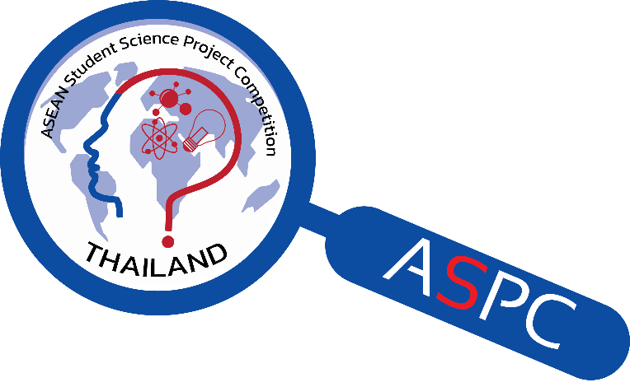

The 9th ASEAN Student
Science Project Competition
(ASPC 2023)

1 – 5 July 2023

At
National Science Museum Thailand (NSM)

Registration Form

Organized by

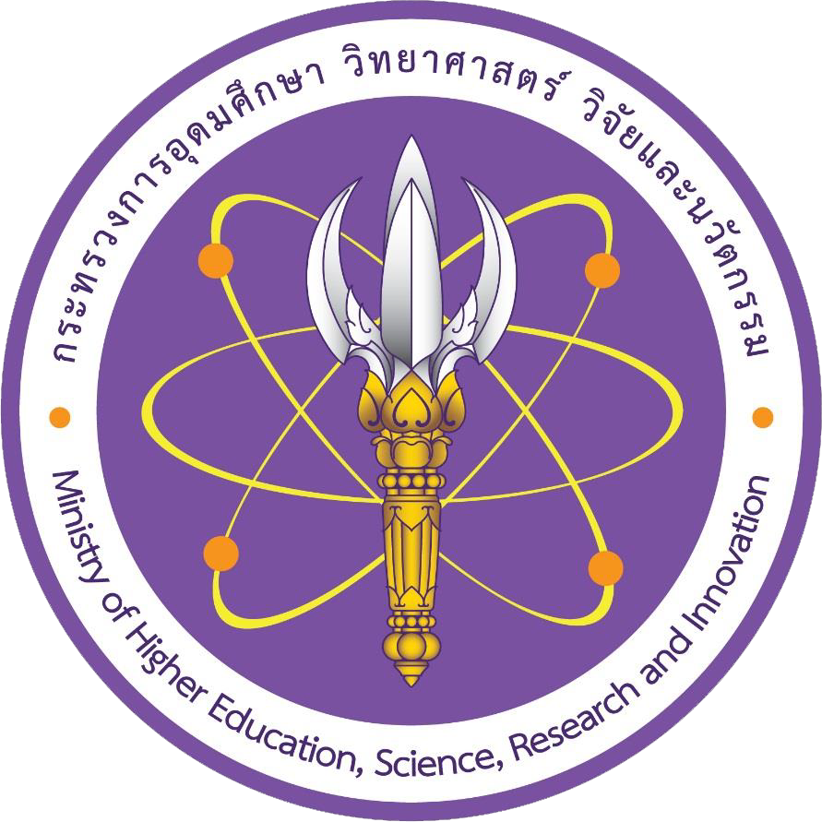
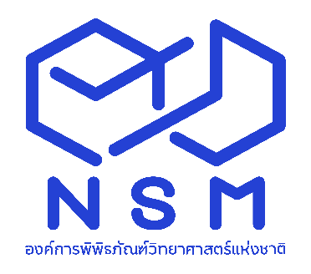

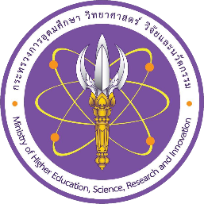
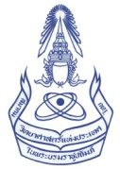

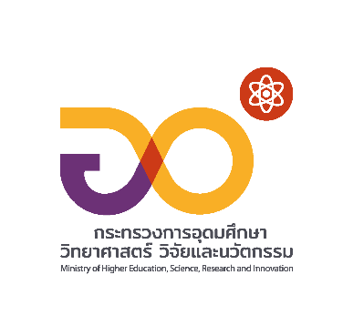

ATTACHMENT # 1
The 9th ASEAN Student Science Project Competition (ASPC 2023)
The REPLY SLIP
===========================================================
If your country is interested to participate in this event, please fill-in this Reply Slip and return to ASPC 2023 organizer by 28 February 2023

- Country : ……………………………………..…………………………..…………………………………

- Contact Person
Full Name
Position
Organization
Address
Tel # |  | Mobile #
E-mail Address

- We would like to send the participants and projects as follows:
Participants | Number of participants (fill in the number)
How many Projects? (Maximum of 6)
How many Students (Grade 9 – 12) ? (Maximum of 12)
How many teacher ? (Maximum of 2)
Would you like to send on one (1) Representative Judge? | - Not send  - Yes, we will send one person
Would you like to send one Adult in Charged to participate? | - Not send  - No, Representative judge will also be Adult in charged  - Yes, we will send one person.

Please return this Reply Slip by 28 February 2023
E-mail To: aspc2Thailand@gmail.com
cc: patcharaporn@nsm.or.th and Kittapard@nsm.or.th
Attention: Ms.Patcharaporn (Pick) Kanngan/ Mr.Kittapard (Tum) Yala
Tel: (+66) 2 577 9999 ext. 1430, Fax: (+66 ) 2 577 9990
ATTACHMENT # 2 - STUDENT

The 9th ASEAN Student Science Project Competition (ASPC 2023)

REGISTRATION FORM & ABSTRACT
===========================================================

- Country: …………………………………………………………………………………………

- Project information

Title of the Project:
………………………………………………………………………………………….………………
………………………………………………………………………………………….………………
………………………………………………………………………………………………………….
Project Category (select one):
- Physical Sciences
- Biological Sciences
- Applied Sciences
Note: After submitting the Registration form, the participant CANNOT change the project type and the category. The participant MUST check carefully before selecting category.
Has this project ever won any awards from the following events? (Select all that applied)
- Regeneron ISEF in the year.……………………………………………………………………
- Genius Olympiad in the year………...........................................................................……
- European Union Contest for Young Scientists (EUCYS) in the year ………………..........
- Beijing Youth Science Creation Competition (BYSCC) in the year ……..…………........
- International Conference of Young Scientists (ICYS) in the year ……..……..…….......
- Taiwan International Science Fair (TISF) in the year ………………………
- Another event, which has more 10 Countries to join to the event. ..……………………....
Has this project ever competed the following events? (Select all that applied)
- ASPC, ASEAN Student Science Project Competition 2015
- ASPC, ASEAN Student Science Project Competition 2016
- ASPC, ASEAN Student Science Project Competition 2017
- ASPC, ASEAN Student Science Project Competition 2018
- ASPC, ASEAN Student Science Project Competition 2019
- ASPC, ASEAN Student Science Project Competition 2021
- ASPC, ASEAN Student Science Project Competition 2022
Name of Students who own this project and will participate in the ASPC 2023.
(Maximum of 2 students per project)
Student #1: Name …………………………………………………………………………………..
Student #2: Name …………………………………………………………………………………..
Abstract of selected project:
Must be typed in ENGLISH.
Contents of Abstract: (maximum 250 words) must include:
1. Purpose of the research
2. Procedures
3. Results
4. Conclusions
………………………………………………………………………………………………………….
………………………………………………………………………………………………………….
………………………………………………………………………………………………………….
………………………………………………………………………………………………………….
………………………………………………………………………………………………………….
………………………………………………………………………………………………………….
………………………………………………………………………………………………………….
………………………………………………………………………………………………………….
………………………………………………………………………………………………………….
………………………………………………………………………………………………………….
………………………………………………………………………………………………………….
………………………………………………………………………………………………………….
………………………………………………………………………………………………………….
………………………………………………………………………………………………………….
………………………………………………………………………………………………………….
………………………………………………………………………………………………………….
………………………………………………………………………………………………………….
………………………………………………………………………………………………………….
………………………………………………………………………………………………………….
………………………………………………………………………………………………………….
………………………………………………………………………………………………………….
………………………………………………………………………………………………………….
………………………………………………………………………………………………………….

- Students’ information:

1. Student # 1
Full Name (as in passport): |  |  | Passport Number:
Age: | Gender: |  | Grade (9 – 12) :
Special Dietary Requirements |  | Religion:
Name of School

Email :
Tel / Mobile# :
Emergency Contact
Name : …………………………………………………………………..…………………….…
Relationship : ……………………………………………………………………………………
Email : ……………………………………………..Tel / Mobile : ………………………….…

2. Student # 2

Full Name (as in passport): |  |  | Passport Number:
Age: | Gender: |  | Grade (9 – 12) :
Special Dietary Requirements |  | Religion:
Name of School

Email :
Tel / Mobile# :
Emergency Contact
Name : …………………………………………………………………..…………………….…
Relationship : ……………………………………………………………………………………
Email : ……………………………………………..Tel / Mobile : ………………………….…

- ABSTRACT OF PROJECT
- Country: …………………………………………………………….…………….…………………………
- Category (select one):
- Physical Sciences
- Biological Sciences
- Applied Sciences
- Project Title: ……………….……………………...………………………………………………………
- Students’ name
1) ……….………..................…………….………………………………………………………………
2) ………….…………...………………………………….………………………………………….……
Contents of Abstract: (maximum 500 words) must include:
1. Purpose of the research
2. Procedures
3. Data
4. Conclusions/Findings
MUST be typed in ENGLISH / Can use another separated sheet, if necessary.

Please return this Registration and Abstract Form by 26 May 2023
E-mail To: aspc2Thailand@gmail.com
cc: patcharaporn@nsm.or.th and Kittapard@nsm.or.th
Attention: Ms.Patcharaporn (Pick) Kanngan/ Mr.Kittapard (Tum) Yala
Tel: (+66) 2 577 9999 ext. 1430, Fax: (+66 ) 2 577 9990

This form is Certified by: …..……………………………… Signature : …………………………………….
(Contact person of the country, Teacher, or Adult in Charge can certified)

ATTACHMENT # 3 - TEACHER

The 9th ASEAN Student Science Project Competition (ASPC 2023)

REGISTRATION FORM

Country : ………………………………………………………………………………………….………...

Teacher’s detail (maximum 2 persons for one country):

Teacher # 1
Full Name (as in passport): |  | Passport Number:
Age: | Gender: |  | Religion:
Special Dietary Requirements |  | Emergency Contact  Name : …………………………………………………  Relationship : …………………………………………  Email : ……………………………………..…………..  Tel / Mobile (country code-number) :  ………………………………………………………..
Name of School

Email : …………………………………..…………..
Tel / Mobile : ………………………………………..
Fax:……………………………..…………….………..

Teacher # 2
Full Name (as in passport): |  | Passport Number:
Age: | Gender: |  | Religion:
Special Dietary Requirements |  | Emergency Contact  Name : …………………………………………………  Relationship : …………………………………………  Email : ……………………………………..…………..  Tel / Mobile (country code-number) :  ………………………………………………………..
Name of School

Email : …………………………………..…………..
Tel / Mobile : ………………………………………..
Fax:……………………………..…………….………..

Please return this Registration and Abstract Form by 26 May 2023
E-mail To: aspc2Thailand@gmail.com
cc: patcharaporn@nsm.or.th and Kittapard@nsm.or.th
Attention: Ms.Patcharaporn (Pick) Kanngan/ Mr.Kittapard (Tum) Yala
Tel: (+66) 2 577 9999 ext. 1430, Fax: (+66 ) 2 577 9990

ATTACHMENT # 4

A REPRESENTATIVE JUDGE / ADULT IN CHARGE (Optional)
The 9th ASEAN Student Science Project Competition (ASPC 2023)
REGISTRATION FORM
===========================================================
Please fill in this form, if ONLY you will be the Representative Judge / Adult in Charge for your country.

Country : ……………………………………………………………………………………………….…….…
Select below:
- Adult in Charge
- Representative Judge
- I will be both position for my country

All items must be filled
Full Name (as in passport): |  | Passport Number:
Age: | Gender: |  | Religion:
Special Dietary Requirements |  | Emergency Contact  Name : …………………………………………………  Relationship : …………………………………………  Email : ……………………………………..…………..  Tel / Mobile : …………………………………………..
Name of Organization

Position
Description of your work in brief

Field of expertise in Science (for representative judge only):

Email : …………………………………..……………………Tel / Mobile : ………………..……………………..

Please return this Registration and Abstract Form by 26 May 2023
E-mail To: aspc2Thailand@gmail.com
cc: patcharaporn@nsm.or.th and Kittapard@nsm.or.th
Attention: Ms.Patcharaporn (Pick) Kanngan/ Mr.Kittapard (Tum) Yala
Tel: (+66) 2 577 9999 ext. 1430, Fax: (+66 ) 2 577 9990

National Science Museum Thailand (NSM)
Ministry of Higher Education, Science, Research and Innovation
39 Moo 3, Klong 5, Khlong Luang, Pathum Thani 12120 Thailand
Tel: (+66) 2 577 9999, Fax: (+66) 2 577 9900, www.nsm.or.th

The Science Society of Thailand
Under the Patronage of His Majesty the King
Faculty of Science, Chulalongkorn University
Phayathai Road, Pathumwan, Bangkok 10330
Tel: (+66) 2 252 4516, (+66) 2 218 5245, Fax (+66) 2 252 4516

