

**The 10th ASEAN Student**

**Science Project Competition**

**(ASPC 2024)**

**2 – 7 July 2024**

**At**

**National Science Museum Thailand (NSM)**

**The Reply Slip**

**Organised by**



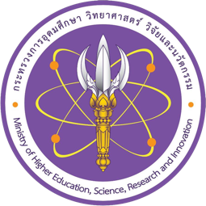



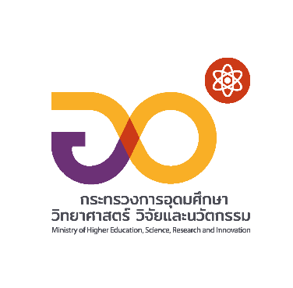







**ATTACHMENT**

The 10th ASEAN Student Science Project Competition (ASPC 2024)

**The REPLY SLIP**

**===========================================================**

If your country is interested in participating in this event, please fill in this Reply Slip and return it to the ASPC 2024 organizer by 29 February 2024

* **Country**: ……………………………………..…………………………..…………………………………
* **Contact Person**

|  |  |  |  |
| --- | --- | --- | --- |
| Full Name |  | | |
| Position |  | | |
| Organisation |  | | |
| Address |  | | |
| Tel |  | Mobile |  |
| E-mail Address |  | | |

* **We would like to send the participants and projects as follows:**

|  |  |
| --- | --- |
| **Participants** | **Number of participants (fill in the number)** |
| **How many Projects?** (Maximum of 6) |  |
| **How many Students (Grades 9 – 12)?** (Maximum of 12) |  |
| **How many teachers?** (Maximum of 2) |  |
| **Would you like to send one (1) Representative Judge?** | * Not send * Yes, we will send one person. |
| **Would you like to send one Adult in Charge to participate?** | * Not send * No, Representative judge will also be Adult in Charge. * Yes, we will send one person. |

**Please return this Reply Slip by 29 February 2024**

E-mail To: aspc2Thailand@gmail.com

cc: patcharaporn@nsm.or.th and pingpayao.k@nsm.or.th

Attention: Ms.Patcharaporn (Pick) Kanngan

Ms.Pingpayao (Nam Kaeng) Keitsinmanon

Tel: (+66) 2 577 9999 ext. 1793, Fax: (+66) 2 577 9990

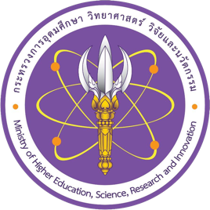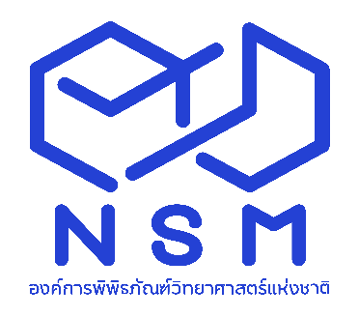

National Science Museum Thailand (NSM)

Ministry of Higher Education, Science, Research and Innovation

39 Moo 3, Klong 5, Khlong Luang, Pathum Thani 12120 Thailand

Tel: (+66) 2 577 9999, Fax: (+66) 2 577 9900, www.nsm.or.th



The Science Society of Thailand

Under the Patronage of His Majesty the King

Faculty of Science, Chulalongkorn University

Phayathai Road, Pathumwan, Bangkok 10330

Tel: (+66) 2 252 4516, (+66) 2 218 5245, Fax (+66) 2 252 4516