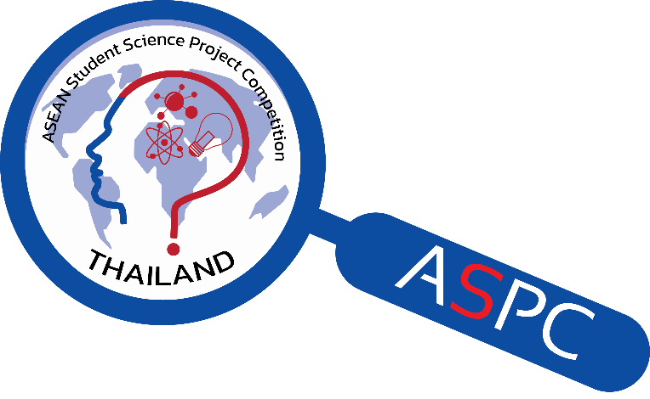

**The 10th ASEAN Student**

**Science Project Competition**

**(ASPC 2024)**

**2 – 7 July 2024**

**At**

**National Science Museum Thailand (NSM)**

**Registration Form**

**Organised by**



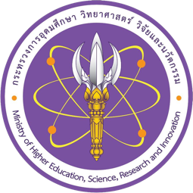

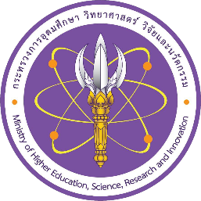

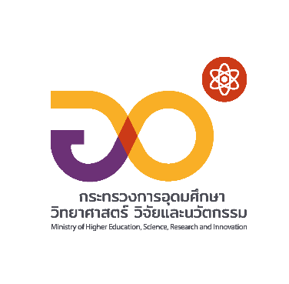

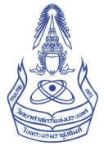





**ATTACHMENT # 1 - STUDENT**

The 10th ASEAN Student Science Project Competition (ASPC 2024)

**REGISTRATION FORM & ABSTRACT**

**===========================================================**

* **Country:** ………………………………………………………………………………………………….
* **Project Title*:** …………………………………………………………………………………………….
* **Project Category\*** (select one)**:** 
  + Physical Sciences
  + Biological Sciences
  + Applied Sciences

**\*Note:** After submitting the Registration form, the participant **CANNOT** change the project title and the category.

* **Name of Students who own this project and will participate in the ASPC 2024.**

(Maximum of 2 students per project)

1) ………………………………………………………………………………………………………….

2) ………………………………………………………………………………………………………….

* **Abstract of the project** (Must be typed in ENGLISH)

Contents of Abstract: (maximum 250 words) must include:

* + Purpose of the research
  + Procedures
  + Results/Findings
  + Conclusions/Discussions

|  |
| --- |
| ………………………………………………………………………………………………………….  ………………………………………………………………………………………………………….  ………………………………………………………………………………………………………….  ………………………………………………………………………………………………………….  ………………………………………………………………………………………………………….  ………………………………………………………………………………………………………….  ………………………………………………………………………………………………………….  ………………………………………………………………………………………………………….  ………………………………………………………………………………………………………….  ………………………………………………………………………………………………………….  ………………………………………………………………………………………………………….  ………………………………………………………………………………………………………….  ………………………………………………………………………………………………………….  ………………………………………………………………………………………………………………………………………………………………………………………………………………………… |
| **I certify that this project has never received any awards from the following events below.**   * Regeneron ISEF * Genius Olympiad * European Union Contest for Young Scientists (EUCYS) * Beijing Youth Science Creation Competition (BYSCC) * International Conference of Young Scientists (ICYS) * Taiwan International Science Fair (TISF) * Any other events, which has more 10 countries participating in the event   **I certify that this project has never participated in ASPC.** |

* **Students’ information:**

**1. Student # 1**

|  |  |  |  |
| --- | --- | --- | --- |
| Full Name (as in passport): | | | Passport Number: |
| Age: | Gender: | | Grade (9 – 12): |
| Special dietary requirements | | Religion: | |
| Name of School: | | | |
| Email: | | | |
| Tel / Mobile: | | | |
| **Emergency Contact:**  Name: …………………………………………………………………..…………………….  Relationship: …………………………………………………………………………………  Email: ……………………………………………. Tel / Mobile: ………………………. …. | | | |

**2. Student # 2**

|  |  |  |  |
| --- | --- | --- | --- |
| Full Name (as in passport): | | | Passport Number: |
| Age: | Gender: | | Grade (9 – 12): |
| Special dietary requirements | | Religion: | |
| Name of School: | | | |
| Email: | | | |
| Tel / Mobile: | | | |
| **Emergency Contact:**  Name: …………………………………………………………………..…………………….  Relationship: …………………………………………………………………………………  Email: ……………………………………………..Tel / Mobile: ………………………….. | | | |

**This form is Certified by:** …..…………………………… **Signature:** ………………………………

(Contact person of the country, Teacher, or Adult in Charge can certified)

**Please return this Registration and Abstract Form by 27 May 2024**

E-mail To: aspc2Thailand@gmail.com

cc: patcharaporn@nsm.or.th and pingpayao.k@nsm.or.th

Attention: Ms.Patcharaporn (Pick) Kanngan/

Ms.Pingpayao (Nam Kaeng) Keitsinmanon

Tel: (+66) 2 577 9999 ext. 1793, Fax: (+66) 2 577 9990

**ATTACHMENT # 2 - TEACHER**

The 10th ASEAN Student Science Project Competition (ASPC 2024)

**REGISTRATION FORM**

* **Country**: ………………………………………………………………………………………….……
* **Teacher’s detail** (maximum 2 persons for one country)**:**
* **Teacher # 1**

|  |  |  |  |
| --- | --- | --- | --- |
| Full Name (as in passport): | | Passport Number: | |
| Age: | Gender: | | Religion: |
| Special dietary requirements | | **Emergency Contact:**  Name: ………………………………………………  Relationship: ………………………………………  Email: ……………………………………..…………  Tel / Mobile (country code-number):  ……………………………………………………….. | |
| Name of School: | |
| Email: …………………………………..…………..  Tel / Mobile: ………………………………………..  Fax: ……………………………..…………….…… | |

* **Teacher # 2**

|  |  |  |  |
| --- | --- | --- | --- |
| Full Name (as in passport): | | Passport Number: | |
| Age: | Gender: | | Religion: |
| Special dietary requirements | | **Emergency Contact:**  Name: …………………………………………………  Relationship: …………………………………………  Email: ……………………………………..…………..  Tel / Mobile (country code-number):  ………………………………………………………… | |
| Name of School: | |
| Email: …………………………………..…………..  Tel / Mobile: ………………………………………..  Fax: ……………………………..…………….…… | |

**Please return this Registration and Abstract Form by 27 May 2024**

E-mail To: aspc2Thailand@gmail.com

cc: patcharaporn@nsm.or.th and pingpayao.k@nsm.or.th

Attention: Ms.Patcharaporn (Pick) Kanngan/

Ms.Pingpayao (Nam Kaeng) Keitsinmanon

Tel: (+66) 2 577 9999 ext. 1793, Fax: (+66) 2 577 9990

**ATTACHMENT # 3**

**A REPRESENTATIVE JUDGE / ADULT IN CHARGE (Optional)**

The 10th ASEAN Student Science Project Competition (ASPC 2024)

**REGISTRATION FORM**

**===========================================================**

**Please fill in this form, if ONLY you will be the Representative Judge / Adult in Charge for your country.**

* **Country**: ……………………………………………………………………………………………….
* **Affiliation:**
* Adult in Charge
* Representative Judge
* I will be both position for my country
* **Personal information**

|  |  |  |  |
| --- | --- | --- | --- |
| Full Name (as in passport): | | Passport Number: | |
| Age: | Gender: | | Religion: |
| Special dietary requirements | | **Emergency Contact:**  Name: …………………………………………………  Relationship: …………………………………………  Email: ……………………………………..…………..  Tel / Mobile: ………………………………………….. | |
| Name of Organization: | |
| Position: | |
| Description of your work in brief | | | |
| Field of expertise in science (for representative judge only): | | | |
| Email: …………………………………..…………………Tel / Mobile: ………………..……………………. | | | |

**Please return this Registration Form by 27 May 2024**

E-mail To: aspc2Thailand@gmail.com

cc: patcharaporn@nsm.or.th and pingpayao.k@nsm.or.th

Attention: Ms.Patcharaporn (Pick) Kanngan/

Ms.Pingpayao (Nam Kaeng) Keitsinmanon

Tel: (+66) 2 577 9999 ext. 1793, Fax: (+66) 2 577 9990

**ATTACHMENT # 4**

**Observers**

The 10th ASEAN Student Science Project Competition (ASPC 2024)

**REGISTRATION FORM**

**===========================================================**

**Please fill in this form, if ONLY you will be the Observers for your country.**

* **Country**: ……………………………………………………………………………………………….
* **Personal information**

|  |  |  |  |
| --- | --- | --- | --- |
| Full Name (as in passport): | | Passport Number: | |
| Age: | Gender: | | Religion: |
| Special dietary requirements | | **Emergency Contact:**  Name: …………………………………………………  Relationship: …………………………………………  Email: ……………………………………..…………..  Tel / Mobile: ………………………………………….. | |
| Name of Organization: | |
| Position: | |
| Description of your work in brief | | | |
| Participation purpose | | | |
| Email: …………………………………..…………………Tel / Mobile: ………………..……………………. | | | |

**Please return this Registration Form by 27 May 2024**

E-mail To: aspc2Thailand@gmail.com

cc: patcharaporn@nsm.or.th and pingpayao.k@nsm.or.th

Attention: Ms.Patcharaporn (Pick) Kanngan/

Ms.Pingpayao (Nam Kaeng) Keitsinmanon

Tel: (+66) 2 577 9999 ext. 1793, Fax: (+66) 2 577 9990

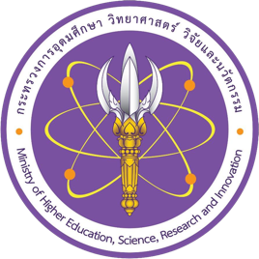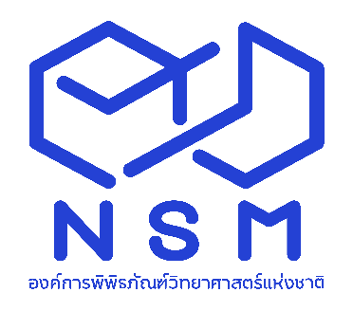

National Science Museum Thailand (NSM)

Ministry of Higher Education, Science, Research and Innovation

39 Moo 3, Klong 5, Khlong Luang, Pathum Thani 12120 Thailand

Tel: (+66) 2 577 9999, Fax: (+66) 2 577 9900, www.nsm.or.th



The Science Society of Thailand

Under the Patronage of His Majesty the King

Faculty of Science, Chulalongkorn University

Phayathai Road, Pathumwan, Bangkok 10330

Tel: (+66) 2 252 4516, (+66) 2 218 5245, Fax (+66) 2 252 4516